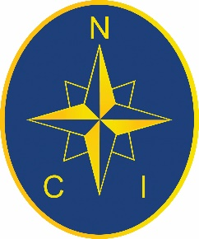 | SWANAGE  NATIONAL COASTWATCH  INSTITUTION |  |  |  |  | 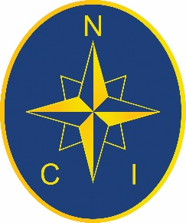
Wednesday 1stJanuary 2025
HIGH WATER |  |  |  | 09:30 | 21:51
EBB |  |  |  | 11:15 | 23:36
LOW WATER |  | 04:12 |  | 16:34
FLOOD |  | 05:28 |  | 17:45
SUNRISE – 08:09 |  |  |  | SUNSET – 16:13
Depths of Low Water
At Pier Head: |  |  | 2.95 | Next Spring Tide: | 1st Jan 2025
Over chart datum: |  |  | 0.45 | Next Neap Tide: | 8th Jan 2025

General Weather Synopsis -
During New Year's Day an arctic airmass over Scotland will move southwards. Strong winds and gales will cover all waters, with severe gales affecting the English Channel at first.

Inshore Waters Forecast
Issued at: 06:00 (UTC) on Wed 1 Jan 2025
For coastal areas up to 12 miles offshore for the period 06:00 (UTC) on Wed 1 Jan 2025 to 06:00 (UTC) on Thu 2 Jan 2025

Selsey Bill to Lyme Regis - Strong Winds are forecast
Wind: Southwesterly 7 to severe gale 9, occasionally storm 10 at first in east, veering westerly or northwesterly 4 to 6, then veering northerly 4 or 5 later.
Sea state: Rough or very rough, becoming moderate, occasionally slight later.
Weather: Rain at times, fair later.
Visibility: Moderate or poor, occasionally good.
.

Outlook for the following 24 hours:
Wind: Northerly 4 or 5, occasionally 3 later.
Sea state: Slight or moderate.
Weather: Fair.
Visibility: Good.

